* Clear to navigate between sections
* No obtrusions
* Native, fits all the resolutions
* Content [ALL CONTENT MUST HAVE TAGS]
  + About you
  + Personality
  + Picture
* Resume
  + Downloadable
  + View in PDF file
* Contact information
* Social media integration
  + Change facebook to more professional
* PROJECTS
  + Deployable
  + Dungeon Crawler
    - Growth path
      * New projects

. Responsive UI

1. You should include the following <meta> viewport element in all your web pages:

<meta name="viewport" content="width=device-width, initial-scale=1.0">

The width=device-width part sets the width of the page to follow the screen-width of the device (which will vary depending on the device).

The initial-scale=1.0 part sets the initial zoom level when the page is first loaded by the browser.

So, if the user is forced to scroll horizontally, or zoom out, to see the whole web page it results in a poor user experience.

1. **Do NOT use large fixed width elements**
   1. if an image is displayed at a width wider than the viewport it can cause the viewport to scroll horizontally. Remember to adjust this content to fit within the width of the viewport
2. **Do NOT let the content rely on a particular viewport width to render well**
   1. Content should not rely on a certain viewport width for rendering
3. **Use CSS media queries to apply different styling for small and large screens**
   1. Use relative width values, such as width: 100%
   2. Avoid large absolute CSS widths e.g px

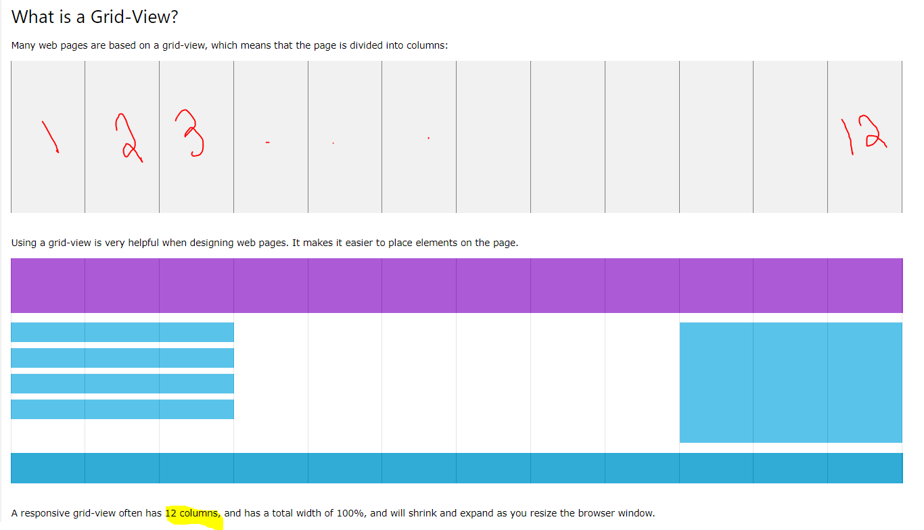

First ensure that all HTML elements have the box-sizing property set to border-box.

This makes sure that the padding and border are included in the total width and height of the elements.

Add the following code in your CSS:

* {  
    box-sizing: border-box;  
}

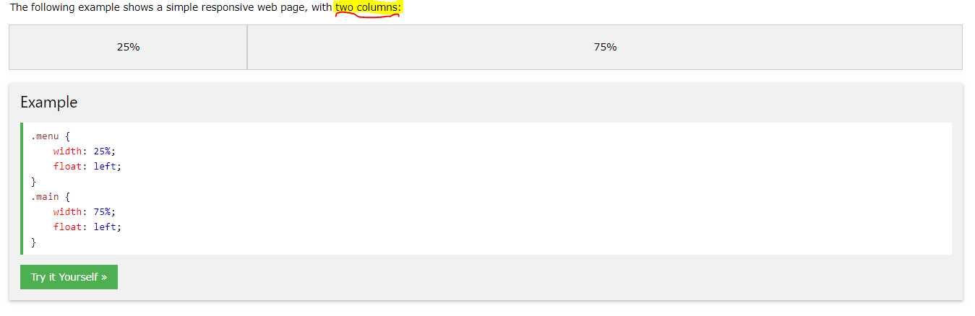

The example above is fine if the web page only contains two columns.

However, we want to use a responsive grid-view with 12 columns, to have more control over the web page.

First we must calculate the percentage for one column: 100% / 12 columns = 8.33%.

1 column = 8.33% of the page (100/12)

Then we make one class for each of the 12 columns, class="col-" and a number defining how many columns the section should span:

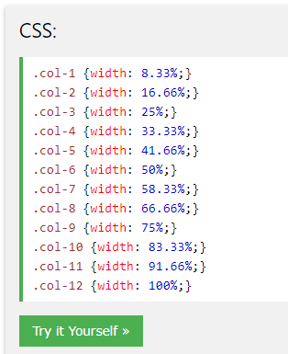

MSA WEDNESDAY ASK SESSION

1. The entire project completed
2. API to portfolio how
3. Deadline not finishing
4. Review